Before You Start
Basic Stitches you will need in this pattern
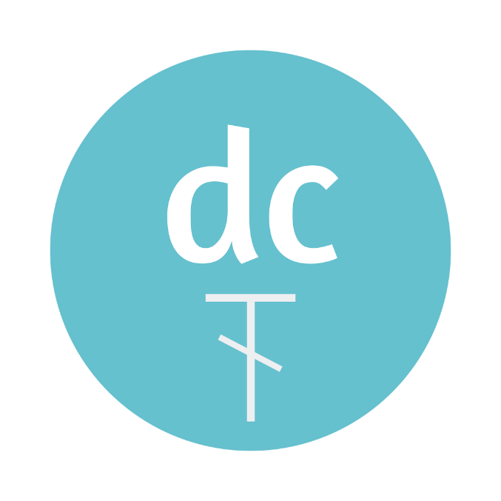

Project 2 – October 2021

This month is texture and I am loving the wrap stitch that is in this design. If you know double crochet (UK treble) and the puff stitch then you’ll pick this one up quickly!

Materials
- 150-200g (up to 485m) Any DK weight/8ply yarn. Choose to suit the season that you want to wear it in. I used Bendigo woollen Mills Cotton.
- 4mm hook
- Needle to weave in ends

Gauge
Not important

Measurements
Approx 17cm x 150cm before the fringe

Abbreviations US terms |UK terms

US TERMS |  | UK TERMS
ss | slip stitch | ss | slip stitch
ch | chain | ch | chain
dc | double crochet | tr | treble
Wrap | Wrap stitch | Wrap | Wrap stitch

Pattern Notes:

If you want to adjust this pattern, chain any multiples of 4 and add 3. If adding it into a row, you’ll need a count of multiples of 4 plus 1.
The fringe is totally up to you to add. I’ve always avoided them, but I’m glad that I make the effort as I think it really completes the piece. I can see this as a boho styled vest in any length.
In this pattern the ch3 at the beginning of a row counts as a double crochet (UK treble).
In this pattern the ch4 at the beginning of a row counts as double crochet, chain 1 (UK treble, chain 1).
You can adjust the length and thickness of the fringe to suit. To make thicker, use more strands of yarn in each stitch. To make longer, cut strands to twice the length you need plus 3-5 cm extra.

PATTERN- US TERMS:

Basic Stitches:
Slip Stitch: Insert your hook into the stitch. YO and pull the yarn through the stitch the continue to pull through the loop on your hook.
Chain: YO and pull the yarn through the loop on your hook.
Double Crochet: YO, insert your hook into the stitch. YO and pull the yarn through the stitch to pull up a loop. You will have 3 loops on your hook. YO, pull through all the first two loops on your hook, YO pull through the last two loops on your hook.

Special Stitches:
Wrap Stitch: Yarn over (YO) and insert your hook around the post of the double crochet just made, YO and pull up a loop. Repeat two more times. YO and pull through all loops on your hook.

Pattern

ROUND | INSTRUCTION
Begin | Chain 35
 | 1dc in the 4th chain from the hook and into each chain across, turn. (33dc)
Ch4 (=1dc, ch1)
- Skip 1, 1dc in the next stitch
- Ch1, skip 1, 1dc in the next stitch
- Repeat the step in bold to the end.
- Turn (17dc, 16ch1 spaces)

Ch4
- Skip the ch1 space, 1dc in the next dc, wrap
- Ch1, skip the ch1 space, 1dc in the next dc
- Ch1, skip the ch1 space, 1dc in the next dc, wrap
- Repeat the steps in bold until only 1 ch1 space and 1dc remain
- Ch1, skip the ch1 space, 1dc in the last dc
- Turn (8 wrap, 9dc, 16ch1 spaces)

Ch4
- Skip the ch1 space, 1dc in the top of the wrap stitch
- Ch1, skip the ch1 space, 1dc in the top of the dc
- Ch1, skip the ch1 space, 1dc in the top of the wrap stitch
- Repeat the steps in bold until only 1 ch1 space and 1dc remain
- Ch1, skip the ch1 space, 1dc in the last dc
- Turn (17dc, 16ch1 spaces)

Ch3
- 1dc in each ch1 space and each dc, turn (33dc)

Row 6-21 | Repeat row 2-5 4 times or until desired length is reached..  Fasten off
Fringe | Fringe is going to be added to both ends of the scarf into every second stitch.  Cut yarn to lengths of approx. 25cm or 10 inches long. You will need 4 strands per stitch you’re adding fringe to – 68 strands for each end – 136 in total.  To add one fringe  - Take two strands of yarn and cut in half  - Insert your hook into the stitch – starting from the back to bring the hook to the front  - Use the hook to pull the folded end through the stitch  - Pull up to half way through the stitch  - Use your fingers or the hook to pull the free ends of the yarn through the loop formed  - Pull on the free ends to pull tight.  - Repeat into every second stitch.  - Trim to even the length or leave as is.

PATTERN - UK TERMS

Basic Stitches (UK Terms):
Slip Stitch: Insert your hook into the stitch. YO and pull the yarn through the stitch the continue to pull through the loop on your hook.
Chain: YO and pull the yarn through the loop on your hook.
Treble: YO, insert your hook into the stitch. YO and pull the yarn through the stitch to pull up a loop. You will have 3 loops on your

Special Stitches:
Wrap Stitch: Yarn over (YO) and insert your hook around the post of the treble just made, yarn over and pull up a loop. Repeat two more times. YO and pull through all loops on your hook

Pattern

ROW | INSTRUCTION
Begin | Chain 23
 | 1tr in the 4th chain from the hook and into each chain across, turn. (33tr)
Ch4 (=1tr, ch1)
- Skip 1, 1tr in the next stitch
- Ch1, skip 1, 1tr in the next stitch
- Repeat the step in bold to the end.
- Turn (17tr, 16ch1 spaces)

Ch4
- Skip the ch1 space, 1tr in the next tr, wrap
- Ch1, skip the ch1 space, 1tr in the next tr
- Ch1, skip the ch1 space, 1tr in the next tr, wrap
- Repeat the steps in bold until only 1 ch1 space and 1tr remain
- Ch1, skip the ch1 space, 1tr in the last tr
- Turn (8 wrap, 9tr, 16ch1 spaces)

Ch4
- Skip the ch1 space, 1tr in the top of the wrap stitch
- Ch1, skip the ch1 space, 1tr in the top of the tr
- Ch1, skip the ch1 space, 1tr in the top of the wrap stitch
- Repeat the steps in bold until only 1 ch1 space and 1tr remain
- Ch1, skip the ch1 space, 1tr in the last tr
- Turn (17tr, 16ch1 spaces)

Ch3
- 1tr in each ch1 space and each tr, turn (21tr)

Row 6-125 | Repeat row 2-5 30 times or until desired length is reached.  Fasten off
Fringe | Fringe is going to be added to both ends of the scarf into every second stitch.  Cut yarn to lengths of approx. 25cm or 10 inches long. You will need 4 strands per stitch you’re adding fringe to – 68 strands for each end – 136 in total.  To add one fringe  - Take two strands of yarn and cut in half  - Insert your hook into the stitch – starting from the back to bring the hook to the front  - Use the hook to pull the folded end through the stitch  - Pull up to half way through the stitch  - Use your fingers or the hook to pull the free ends of the yarn through the loop formed  - Pull on the free ends to pull tight.  - Repeat into every second stitch.  - Trim to even the length or leave as is.

PICTURE GUIDE

Begin | Row 1
Row 2 | Row 3
Row 4 | Row 5
 | 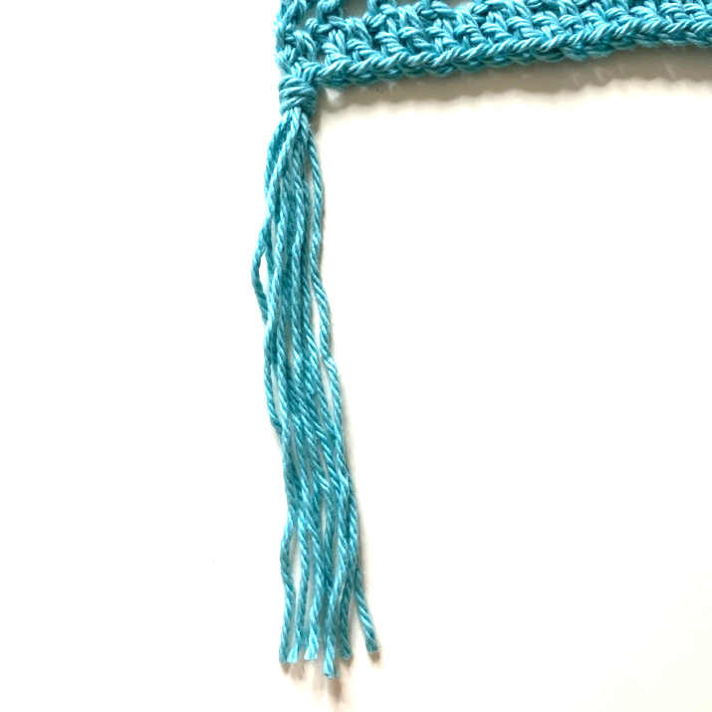
Cut fringe to length | Add fringe…

 | 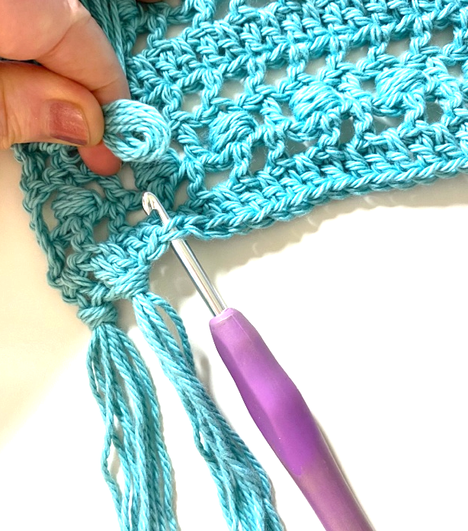
Fold in half | Insert hook from back to front
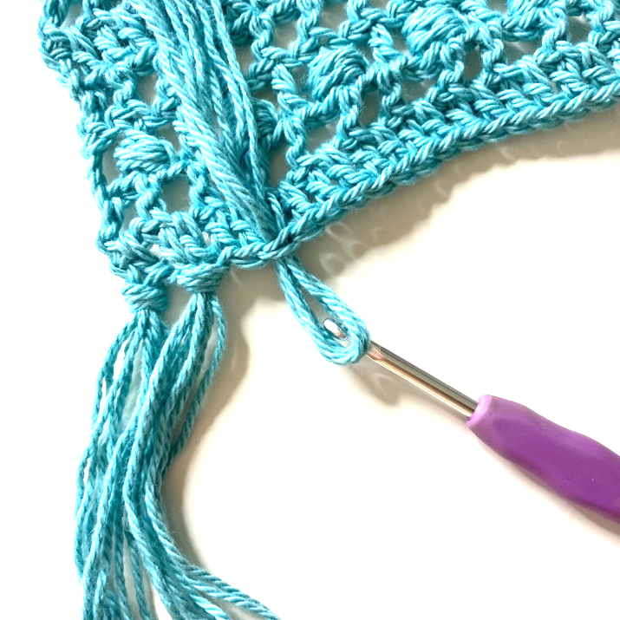 | 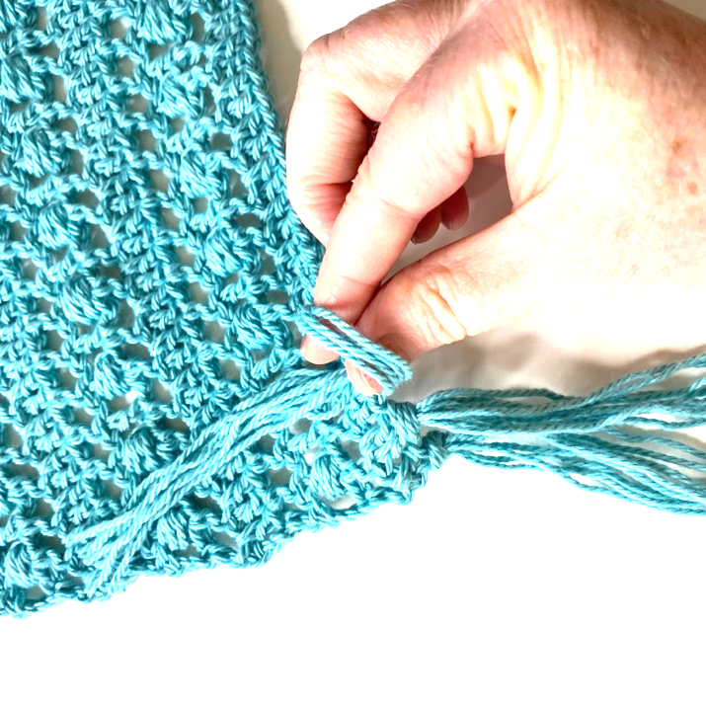
Pull through stitch | Bring ends through loop
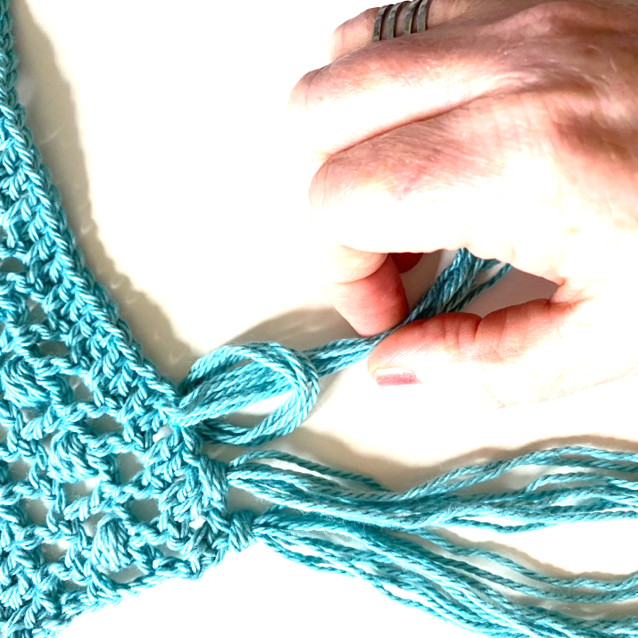 | 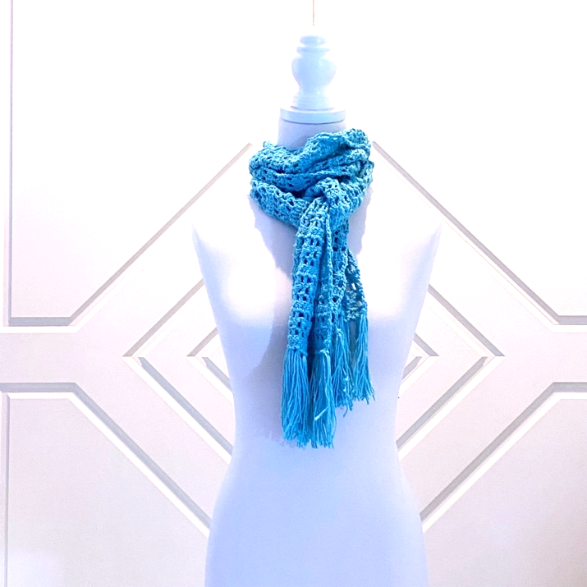
Pull tight | Finish

